

**Misr University for Science & Technology**

**College of Information Technology**

**CS341   
Project Title: Movies Recommendation System**

**Team Members**

**Zyad Mostafa Mohamed - 89481  
Youssef Mostafa Bah-Eldin - 86530**

**Aliaa Mohamed Gabal - 89421**

**Adham Mohamed Alhadodi - 89660**

**Doaa Taha abdelhamed - 89617**

**Supervised by:**

**Dr. Khaled Alsheshtawi   
T.A Ayman S. Abdelaziz**

**Fall/2021-2022**

**System Domain**

A hospital management system is a structured computerized system designed and programmed to handle the day-to-day operations and management of hospital activities. The program can care for inpatients and outpatients, records, database treatments and disease status. It also keeps hospital information such as responsible doctors and department management. The main problem that the patient faces nowadays is to get a report after the consultation, many hospital management reports are in their system but it is not available to the patient when he/she is abroad. In this project, we will provide the additional facility to store the report in the database and make it available.

The hospital management system of the project includes registering patients and storing their data in the system. The software has a facility to give a unique identifier to each patient and stores the details of each patient and staff automatically. User can search for doctor availability and patient details using ID.

The Hospital Management System can be entered using a username and password. It is accessible either by an administrator or receptionist. Only they can add data into the database. The data can be retrieved easily. The interface is very user-friendly. The data are well protected for personal use and makes the data processing very fast.

A robust, flexible and easy to use hospital management system, it has been designed and developed to deliver real, conceivable benefits to hospitals. Hospital Management System is designed for multispecialty hospitals, to cover a wide range of hospital administration and management processes. It is an integrated hospital management system that provides relevant information across the hospital to support effective decision making for patient care and hospital management.

**System Actors**

|  |  |
| --- | --- |
| **Term** | **Definition** |
| Manager | A person who has a full control on the web application |
| System User | The person who controls adding and accessing patient and doctor data |
| Patient | The person who want to get treated and he can access only on his data |
| Doctor | The person who treated and he can access on his data and the patient’s data |

**Functional Requirements**

**REQ1-** Doctors and patient can register on the system by system user.  
**REQ2-** Doctors can add/edit their schedules.  
**REQ3-** Doctors can find their patients and view/edit/add their medical records.  
**REQ4-** Doctors can collect statistics regarding his patients.  
**REQ5-** In the Emergency section the doctor can have access to view the blood bank and book a surgery room.  
**REQ6-** Patients can add the doctor(s) they are following up with.  
**REQ7-** Patients can view different services offered by the hospital.  
**REQ8-** Patients can book appointments with doctors or specific services.  
**REQ9-** Patients can find and pay the fees for the service he has.  
**REQ10-** System user can check the availability of rooms/beds.

**REQ11-** System user can allocate room/bed to a patient.

**REQ12-** System user can transform a patient from one ward to another.  
**REQ13-** The hospital manager can register on the system.

**REQ14-** The hospital manager can delete/view staff from data.  
**REQ15-** The hospital manager monitors the regularity of work in the hospital.

**Non-Functional Requirements**

**REQ1-**Security: Any user who uses the system shall have a Login ID and Password  
**REQ2-**Reliability: (Availability) The system shall be available all the time.  
**REQ3-**Portability: The System must be compatible with both Mobile and Computer devices, so it can be used and accessed at all times.  
**REQ4-**Maintainability: (Back Up) The system shall provide the capability to back-up the Data (Errors) The system shall keep a log of all the errors.  
**REQ5-**The software should have a response time of at most 100 ms.  
**REQ6-**If the software fails for any reason, it should recover within 5 minutes.  
**REQ7-**The project will have a limited budget of 50000.  
**REQ8-**Follows all the applicable copyright laws.  
**REQ9-** It shall be implemented in php.

**UML Diagrams**

**Use case Diagram:**

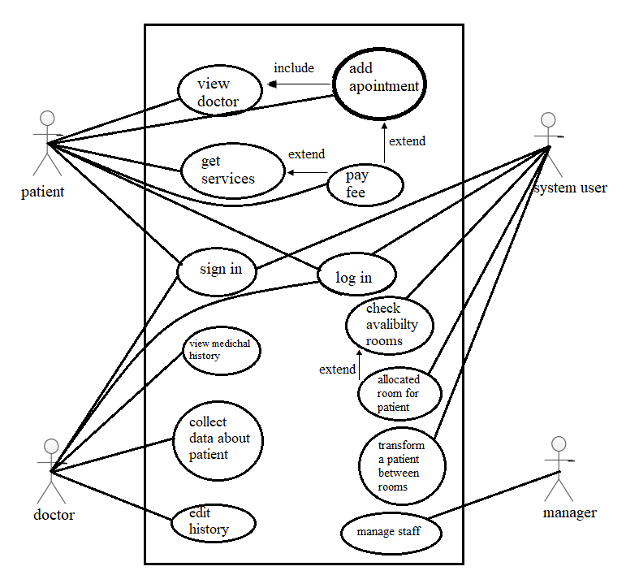

**Context diagram:**

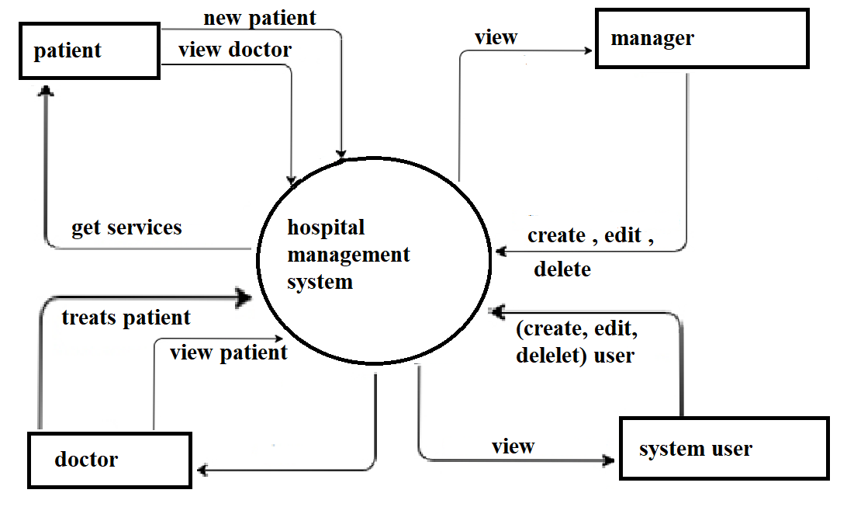

**Sequence Diagrams:**

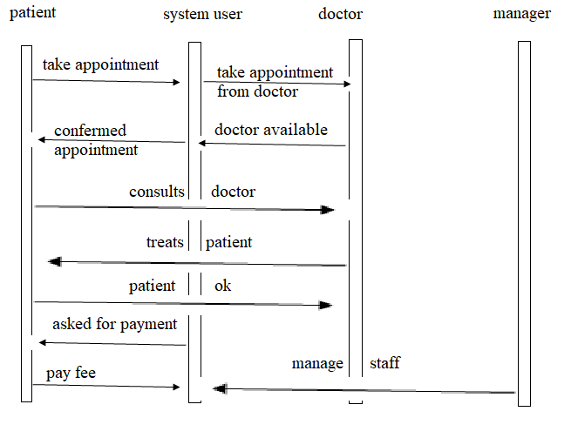

**Activity Diagram:**

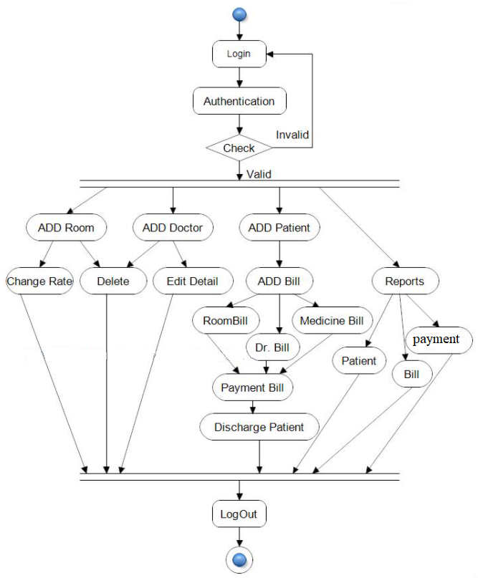

**Class diagram:**

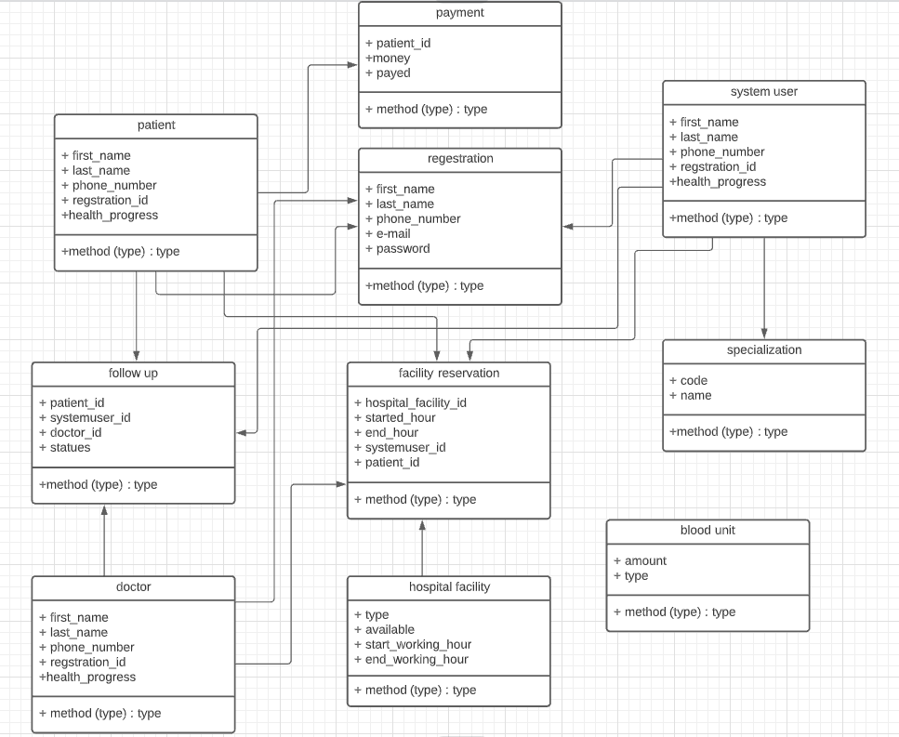

**State diagram:**

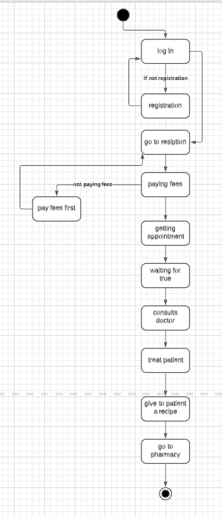

**Code**

